Knowledge Check
- In your own words, what is the purpose of a unit test? “The purpose of a unit test is to test individual parts of the project”
- What happens during the Arrange section of a test? “You create the items needed to test the particular segments of code”
- What happens during the Act section? “In the Act section, you call the method that you want to test to see if it works properly”
- What happens during the Assert section? “You check the results to see if the method actually worked the way you want it to output for its results compared to what it actually produced.”

Before continuing, predict the results of the following method calls:
- Add(5, 3) “I predict it will output 8”
- Add(-2, 7) “I predict it will output 5”
- Subtract(10, 4) “I predict it will output 6”
- Subtract(3, 8) “I predict it will output -5”

Review the test and answer the following questions:
- Which object is created during Arrange? “We are creating the calculator to test it. First, we make the expected result and then set up the method to run. After running the method, you check the expected result with the run method to see if it's correct.”
- What expected result is established? “The expected result of 5 + 3 is 8.”
- Which method is called during Act? “The method being called is the calculator.Add method. This method is supposed to add two numbers together and output the result.”
- What two values are compared during Assert? “The two values being compared are the expected value of calculator.Add(5 + 3) being 8 and the actual output of calculator.Add(5 + 3).”

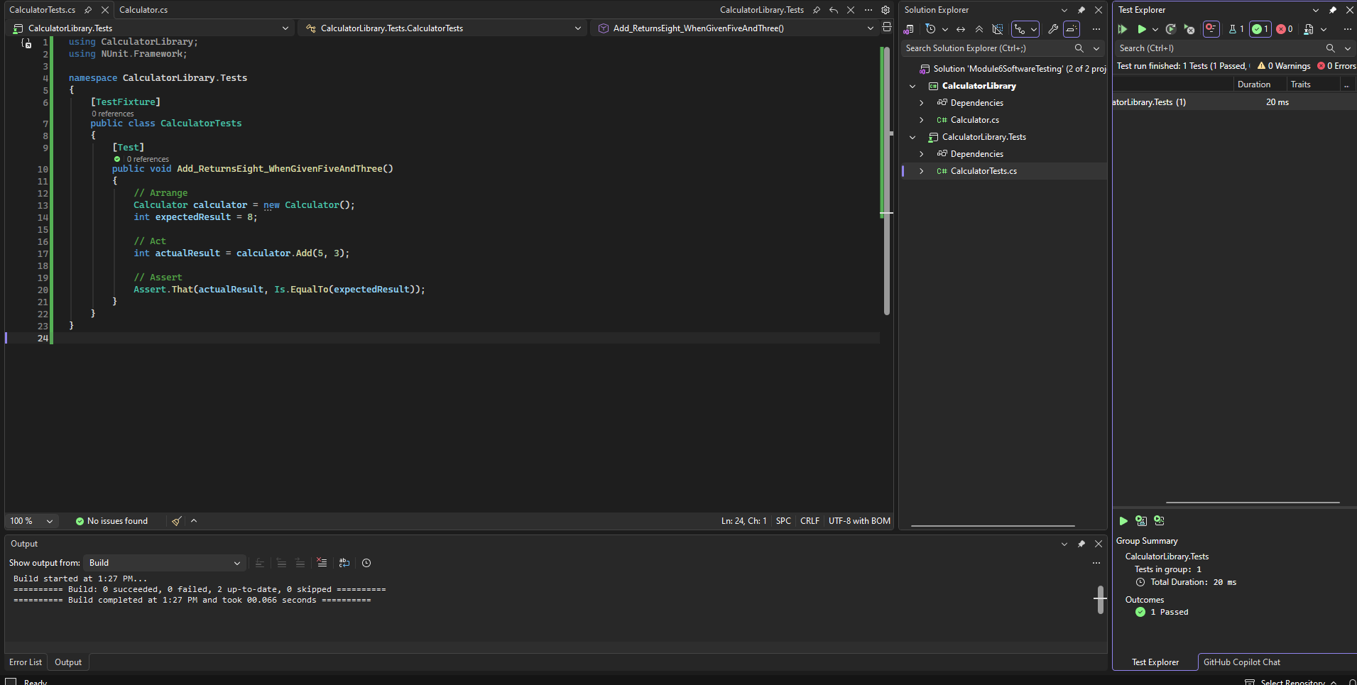

Answer the following:
- What result did the calculator method actually return? “The calculator method resulted in 8.”
- What result did the test expect? “The result the test expected was 10.”
- Why did the test fail? “The test failed because the method's actual result did not match the expected result.”
- How could the failure message help a developer locate a problem? “The failure message helped the developer find out what the result of the tested method was and see that it was not the expected outcome they wanted.”

Checkpoint Questions
- What input values are used in the subtraction test? “The inputs used for the subtraction test are the calculator class, the subtraction method, and the expected result being 6.”
- What result is expected? “The expected result is 6”
- What would happen if Subtract() accidentally used the addition operator? “Subtract would run like normal but may not have the desired expected result.”
- How does the test help confirm that the method works correctly? ”The test ensures that the expected result is the result that happens when tested.”

In your submission document, identify:
- The method you tested
- The input values used
- The expected result
- Why you selected this test condition
- Whether the test passed
“I used the subtraction method for my test. My input values were 0 and -2, and my expected value was 2. I selected this test condition as it involves a zero AND a negative number in a subtraction method to test how it handles subtracting negatives. The test passed, as 0 - -2 is just 0 + 2 in the end.”

Respond to each question using complete sentences.
- What is one benefit of placing tests in a separate project? “The benefit of placing the tests in a separate project is that you can test just the methods you want to test so you don't have to run the whole project up to that point, with the possibility that it crashes, and that you can see the results compared to expected results.”
- Why should a test use known input and an expected result? “A test should use known input and expected output because it can verify that there are no outside factors contributing to the errors and ensure that it works correctly with simple variables”
- How does Arrange, Act, Assert make a test easier to understand? “The three parts of the test make it easier to understand how each part plays together and what all parts of the test involve to use for more tests in the future.”
- What did the failing test demonstrate? “It demonstrates what the expected result was and the actual output of the method to show you why it failed and lets you see if it's the method failing or outside sources.”
- How could unit testing help you improve one of your previous C# assignments? “It can make sure that these methods work on their own with simple tests without requiring the whole project to run. A good example would be my final project as it would allow me to test each method in a controlled environment without having to run a bunch of methods.”
- What part of creating or running the tests was most challenging? “Setting up the actual way to test the methods was the hardest part. Especially setting up the .test section.”

